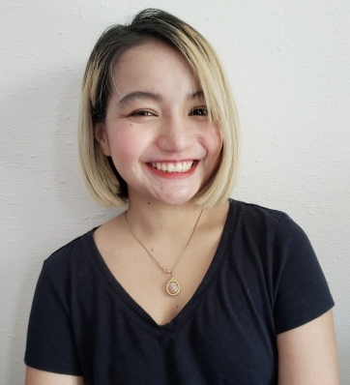
Kanokwan Upatham
5 Benton St. Apt 1/2 Stoneham, MA 02180
Tel: 17812671993
Email: Nnnancy2494@gmail.com

HILIGHTS
Personal Profile
- Date of birth : Jan 24th, 1994
- Sex : Female
- Thai Nationality
- Height 4’11” / Weight 110 lb.
- US Permanent Resident Status

- Creative , Artistic
- Excellent customer service, Full of service mind
- Good communication and negotiation skills
- Energetic personality
- Able to stay focused on the job, event under extreme circumstances.
- Good level of read, write and speak English.

EDUCATION
- BBA. Hospitality and Tourism Management Major - GPA 3.20
International College, SuanSunandha Rajabhat University, Thailand (2015)
- Nail Technician License – Blessing nail channel (Woburn , MA)

WORK EXPERIENCE (THAILAND)

- Product Consultant for part-time job. ( 2012- 2013 )
- Translator and Exhibitor on International Medical Exhibition.
- Banquet staff part time job at Amari Hotel Watergate and Mandarin Oriental Bangkok. ( 2012 – 2015 )
- Passenger Service agent for Bangkok Airway under BAGS handling company. ( Krabi International Airport 2016 )
WORK EXPERIENCE (UNITED STATES)
- Full time Waitress and Appetizer Chef at Sweet Ginger 2, New Hampshire for 1 and half year. ( 2016 – 2017 )
- Part time Waitress (2018)

